**UNIVERSITY OF MISSOURI- ST. LOUIS**

History 1075 Advanced Credit-The World to 1500: Fall Semester 2024

**GATEWAY STEM HIGH SCHOOL**

Advanced Placement World History Modern: Semester 1 2024

**Instructor:** Josh Torres Wedding

**Classroom/Office:** 418 North Gateway STEM

**Office Hours**: Monday and Wednesday—9:00 AM to 10:00 AM

Tuesdays and Thursdays—7:30 AM-8:30 PM

**Email**: joshua.wedding@slps.org

**Website:** https://www.slps.org/Domain/7642

COURSE DESCRIPTION:

The purpose of the AP World History course is to develop a greater understanding of the evolution of global processes and contacts in different types of human societies. This understanding is advanced through a combination of selective content knowledge and appropriate analytical skills. This course will be centered around primary source document analysis, class discussion, and argumentative essay writing that uses evidence to support a thesis. The course highlights the nature of changes in global frameworks and their causes and consequences, as well as comparisons among major societies. It emphasizes relevant factual knowledge, leading interpretive issues, and skills in analyzing types of historical evidence.

For more information on the course, see the [College Board’s overview and course description.](https://apcentral.collegeboard.org/courses/ap-world-history)

The AP World History: Modern framework included in the course and exam description outlines distinct skills that students should practice throughout the year—skills that will help them learn to think and act like historians.

HISTORICAL THINKING SKILLS:

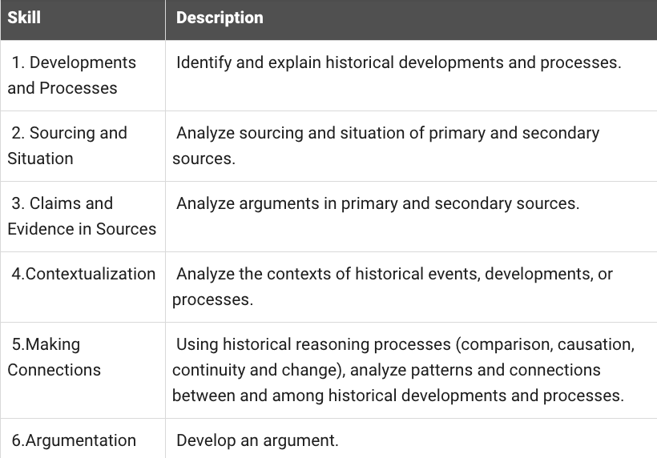

HISTORICAL REASONING PROCESSES:

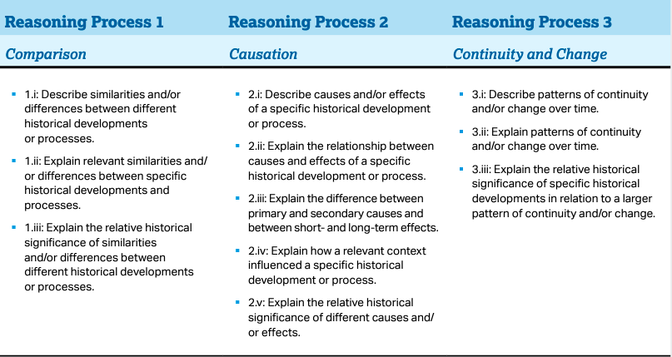

COURSE OBJECTIVES:

1. Master knowledge of world history
2. Effectively use tools of historiography
3. Apply and analyze skills using primary source documents and DBQs
4. Evaluate information and synthesize original thought
5. Understand the themes of Advanced Placement World History
6. Prepare for and perform successfully on the AP Exam

REQUIRED TEXT:

This class will have a required textbook, as well frequent handouts of primary and secondary sources.

AMSCO Publication. *World History Modern: Preparing for the Advanced Placement Examination*. Des Moines, IA: Perfect Learning Corp, 2024

ORGANIZATION OF THE COURSE: *(Note: this is just semester 1-Fall. Look at the Spring semester 2 syllabus for rest of the course.)*

**-Unit 0: Foundations. Early Civilizations to 1200 CE**

**-Unit 1: The Global Tapestry c.1200-1450**

1.1 Developments in East Asia

1.2 Developments in Dar al- Islam

1.3 Developments in South & Southeast Asia

1.4 State Building in the Americas

1.5 State Building in Africa

1.6 Developments in Europe

1.7 Unit Comparisons

**-Unit 2: Networks of Exchange c. 1200-1450**

2.1 The Silk Roads

2.2 Mongols & the Modern World

2.3 Exchange in the Indian Ocean

2.4 Trans-Saharan Trade Routes

2.5 Cultural Consequences of Connectivity

2.6.Environmental Consequences of Productivity

2.7 Comparison of Economic Exchange

**-Unit 3: Land-Based Empires c. 1450-1750**

3.1 Empires Expand

3.2 Mongols & the Modern World

3.3 Empires: Belief Systems

3.4 Land-Based Empire Comparisons

**-Unit 4: Transoceanic Interconnections c. 1450-1750**

4.1 Technological Innovations

4.2 Exploration: Causes & Events

4.3 Columbian Exchange

4.4 Empires Established

4.5 Maritime Empires Maintained & Developed

4.6 Internal and External Challenges to State Power

4.7 Changing Social Hierarchies

4.8 Continuity and Change from 1450-1750

AP WORLD HISTORY THEMES

**THEME 1: HUMANS AND THE ENVIRONMENT (ENV)** The environment shapes human societies, and as populations grow and change, these populations in turn shape their environments.

**THEME 2: CULTURAL DEVELOPMENTS AND INTERACTIONS (CDI**) The development of ideas, beliefs, and religions illustrates how groups in society view themselves, and the interactions of societies and their beliefs often have political, social, and cultural implications.

**THEME 3: GOVERNANCE (GOV)** A variety of internal and external factors contribute to state formation, expansion, and decline. Governments maintain order through a variety of administrative institutions, policies, and procedures, and governments obtain, retain, and exercise power in different ways and for different purposes.

**THEME 4: ECONOMIC SYSTEMS (ECN)** As societies develop, they affect and are affected by the ways that they produce, exchange, and consume goods and services.

**THEME 5: SOCIAL INTERACTIONS AND ORGANIZATION (SIO)** The process by which societies group their members and the norms that govern the interactions between these groups and between individuals influence political, economic, and cultural institutions and organization.

**THEME 6: TECHNOLOGY AND INNOVATION (TEC)** Human adaptation and innovation have resulted in increased efficiency, comfort, and security, and technological advances have shaped human development and interactions with both intended and unintended consequences

ASSIGNMENTS:

Weekly chapter readings will be assigned from both textbooks. Additional homework and class work will consist of primary source document analysis and essay writing. Students will also be expected to engage with a variety of media for assignments, Heimler’s History videos and Freemen-pedia. Links to various resources can also be found on instructor’s website, under the AP World Resources link.

EMAIL PROTOCOL:

On the “Subject” line: Student’s last name--a short description of the subject of the email. Students may also use the Remind app to contact the instructor, after joining the course via the app.

ACCESS AND DISABILITY:

Students requiring special accommodations should contact Gateway STEM Special Education Department or the Counseling Department to document their disability and determine what accommodations will be provided. Once they have this information, they should contact me.

GRADING:

Grade calculation:

40% formative assessments: classwork, homework, etc.

60% summative assessments: quizzes, exams, major projects, etc.

Late work will only be accepted until the end of the current unit, for reduced credit. Students may retake assignments if they are not happy with the grade received. However, make up assignments must be done outside of class time.

Students will receive numerical grades on all assignments ranging from 0-100. Numerical grades can be translated into letter grades according to the following:

A = 90-100 B = 80-89 C = 70-79 D = 60-69 F = 0-59

**If the student’s semester grade is 70 or higher, they have the opportunity to receive three college credit hours from the University of Missouri-St. Louis, Advanced Credit Program. St. Louis Public Schools will pay for the credits if the student receives an 80% or higher.**

AP WORLD HISTORYMODERN EXAM:

The exam is 3 hours and 15 minutes long and students are required to answer

-Multiple-Choice | 55 Questions | 55 Minutes | 40% of Exam Score

-Short Answer | 3 Questions | 40 Minutes | 20% of Exam Score

-Document-Based | 1 question | 60 Minutes | 25% of Exam Score

-Long Essay | 1 question | 15% of Exam Score | 40 minutes

